
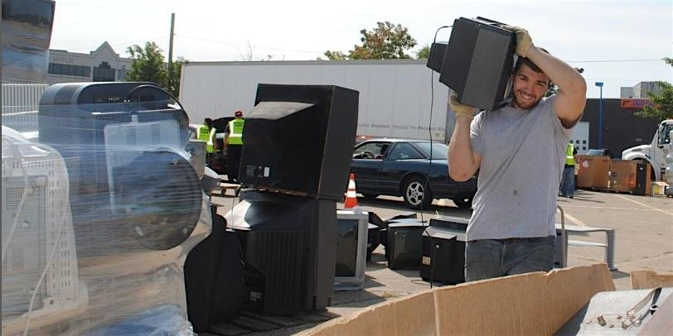
Just added

Hard To Recycle Collection in Quaker Valley
Saturday, October 17, 2026 from 9:00 AM to 1:00 PM (ET)
Buncher Commerce Park • Leetsdale PA
Get my tickets

Buncher Commerce Park Leetsdale, PA
Saturday, October 17 • 9 AM - 1 PM
Overview
PRC is the Commonwealth's oldest environmental nonprofit, working to prevent waste and conserve environmental resources for each generation.
FEES APPLY FOR DISPOSAL OF MATERIAL - Fees paid at event site
EVENT REGISTRATION REQUIRED – One registration per vehicle
FEES AND ACCEPTED MATERIALS:
$5 one-time participation fee for all attendees that covers the unlimited disposal of the following items:
CPU (towers), laptops, mice, & keyboards * Home phones & cellphones * Tablets & UPS, Servers, routers, & modems * DVD Players, VCRs, & stereos * Copiers & scanners, electronic cables * Video game consoles *Styrofoam block * and other small miscellaneous devices * see prc.org/HTR for full list!
Items with a Per-Item Fee:
- $2 per 4-ft fluorescent tube; $4 per 8-ft tube
- $5 per Printer
- $5 per Microwave
- $5 per Electric Lawn Care Tool
- *$6 per Tire (off rim); $14 per Tire (on rim)
- $10 per Small Freon Containing Device (window a/c, dehumidifier, mini fridge)
- $20 per Computer Monitors (flat screen & CRT)
- $35 per TV (Flat Screen & CRT)
- $45 per TV (Console or Rear Projection)
- **$11 for first Certificate of Hard Drive Destruction (optional)
- **$3 per subsequent Certificate of Hard Drive Destruction (optional)
*Tire fees listed are for car and pickup truck tires. Larger tires are subject to larger fees (contact info@prc.org). Also contact us if you plan to bring more than 15 tires.
**Certificates of destruction are optional. All hard drives are wiped regardless of whether one needs a certificate.
Procedures & Policies
- Cash Payment Preferred. Also accept payment via card or check
- Place materials in trunk or truck bed to receive optimal service
Please remember to arrive within the time you register for. All registered participants are guaranteed the opportunity to turn over their materials. Event line closes promptly at 1pm.
Disclaimer: Pictures may be taken at PRC events to help document and promote our vital work. By registering for this event participants acknowledge awareness of that policy. If you prefer PRC NOT use photos of you, please notify event staff. Any participant reported to be rude or harassing any personnel on site will be denied service.

